**28/08/23**

**PROGRAM1: To implement binary search tree.**

**Code:**

#include <stdio.h>

#include <stdlib.h>

struct node {

int key;

struct node *left, *right;

};

// Create a node

struct node *newNode(int item) {

struct node *temp = (struct node *)malloc(sizeof(struct node));

temp->key = item;

temp->left = temp->right = NULL;

return temp;

}

// Inorder Traversal

void inorder(struct node *root) {

if (root != NULL) {

// Traverse left

inorder(root->left);

// Traverse root

printf("%d -> ", root->key);

// Traverse right

inorder(root->right);

}

}

// Insert a node

struct node *insert(struct node *node, int key) {

// Return a new node if the tree is empty

if (node == NULL) return newNode(key);

// Traverse to the right place and insert the node

if (key < node->key)

node->left = insert(node->left, key);

else

node->right = insert(node->right, key);

return node;

}

// Find the inorder successor

struct node *minValueNode(struct node *node) {

struct node *current = node;

// Find the leftmost leaf

while (current && current->left != NULL)

current = current->left;

return current;

}

// Deleting a node

struct node *deleteNode(struct node *root, int key) {

// Return if the tree is empty

if (root == NULL) return root;

// Find the node to be deleted

if (key < root->key)

root->left = deleteNode(root->left, key);

else if (key > root->key)

root->right = deleteNode(root->right, key);

else {

// If the node is with only one child or no child

if (root->left == NULL) {

struct node *temp = root->right;

free(root);

return temp;

} else if (root->right == NULL) {

struct node *temp = root->left;

free(root);

return temp;

}

// If the node has two children

struct node *temp = minValueNode(root->right);

// Place the inorder successor in position of the node to be deleted

root->key = temp->key;

// Delete the inorder successor

root->right = deleteNode(root->right, temp->key);

}

return root;

}

// Driver code

int main() {

struct node *root = NULL;

root = insert(root, 8);

root = insert(root, 3);

root = insert(root, 1);

root = insert(root, 6);

root = insert(root, 7);

root = insert(root, 10);

root = insert(root, 14);

root = insert(root, 4);

printf("Inorder traversal: ");

inorder(root);

printf("\nAfter deleting 10\n");

root = deleteNode(root, 10);

printf("Inorder traversal: ");

inorder(root);

}

**Sample Input & Output:**

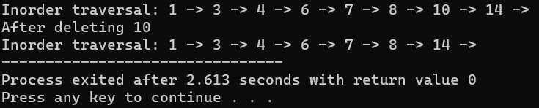

**PROGRAM2: To implement AVL tree.**

**Code:**#include <stdio.h>

#include <stdlib.h>

// Create Node

struct Node {

int key;

struct Node *left;

struct Node *right;

int height;

};

int max(int a, int b);

// Calculate height

int height(struct Node *N) {

if (N == NULL)

return 0;

return N->height;

}

int max(int a, int b) {

return (a > b) ? a : b;

}

// Create a node

struct Node *newNode(int key) {

struct Node *node = (struct Node *)

malloc(sizeof(struct Node));

node->key = key;

node->left = NULL;

node->right = NULL;

node->height = 1;

return (node);

}

// Right rotate

struct Node *rightRotate(struct Node *y) {

struct Node *x = y->left;

struct Node *T2 = x->right;

x->right = y;

y->left = T2;

y->height = max(height(y->left), height(y->right)) + 1;

x->height = max(height(x->left), height(x->right)) + 1;

return x;

}

// Left rotate

struct Node *leftRotate(struct Node *x) {

struct Node *y = x->right;

struct Node *T2 = y->left;

y->left = x;

x->right = T2;

x->height = max(height(x->left), height(x->right)) + 1;

y->height = max(height(y->left), height(y->right)) + 1;

return y;

}

// Get the balance factor

int getBalance(struct Node *N) {

if (N == NULL)

return 0;

return height(N->left) - height(N->right);

}

// Insert node

struct Node *insertNode(struct Node *node, int key) {

// Find the correct position to insertNode the node and insertNode it

if (node == NULL)

return (newNode(key));

if (key < node->key)

node->left = insertNode(node->left, key);

else if (key > node->key)

node->right = insertNode(node->right, key);

else

return node;

// Update the balance factor of each node and

// Balance the tree

node->height = 1 + max(height(node->left),

height(node->right));

int balance = getBalance(node);

if (balance > 1 && key < node->left->key)

return rightRotate(node);

if (balance < -1 && key > node->right->key)

return leftRotate(node);

if (balance > 1 && key > node->left->key) {

node->left = leftRotate(node->left);

return rightRotate(node);

}

if (balance < -1 && key < node->right->key) {

node->right = rightRotate(node->right);

return leftRotate(node);

}

return node;

}

struct Node *minValueNode(struct Node *node) {

struct Node *current = node;

while (current->left != NULL)

current = current->left;

return current;

}

// Delete a nodes

struct Node *deleteNode(struct Node *root, int key) {

// Find the node and delete it

if (root == NULL)

return root;

if (key < root->key)

root->left = deleteNode(root->left, key);

else if (key > root->key)

root->right = deleteNode(root->right, key);

else {

if ((root->left == NULL) || (root->right == NULL)) {

struct Node *temp = root->left ? root->left : root->right;

if (temp == NULL) {

temp = root;

root = NULL;

} else

*root = *temp;

free(temp);

} else {

struct Node *temp = minValueNode(root->right);

root->key = temp->key;

root->right = deleteNode(root->right, temp->key);

}

}

if (root == NULL)

return root;

// Update the balance factor of each node and

// balance the tree

root->height = 1 + max(height(root->left),

height(root->right));

int balance = getBalance(root);

if (balance > 1 && getBalance(root->left) >= 0)

return rightRotate(root);

if (balance > 1 && getBalance(root->left) < 0) {

root->left = leftRotate(root->left);

return rightRotate(root);

}

if (balance < -1 && getBalance(root->right) <= 0)

return leftRotate(root);

if (balance < -1 && getBalance(root->right) > 0) {

root->right = rightRotate(root->right);

return leftRotate(root);

}

return root;

}

// Print the tree

void printPreOrder(struct Node *root) {

if (root != NULL) {

printf("%d ", root->key);

printPreOrder(root->left);

printPreOrder(root->right);

}

}

int main() {

struct Node *root = NULL;

root = insertNode(root, 2);

root = insertNode(root, 1);

root = insertNode(root, 7);

root = insertNode(root, 4);

root = insertNode(root, 5);

root = insertNode(root, 3);

root = insertNode(root, 8);

printPreOrder(root);

root = deleteNode(root, 3);

printf("\nAfter deletion: ");

printPreOrder(root);

return 0;

}

**Sample Input & Output:**

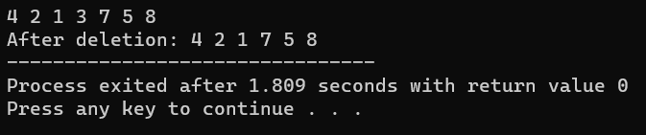

**PROGRAM3: To implement hashing using linear probing.**

**Code:** #include <stdio.h>

#include<stdlib.h>

#define TABLE_SIZE 10

int h[TABLE_SIZE]={NULL};

void insert()

{

int key,index,i,flag=0,hkey;

printf("\nenter a value to insert into hash table\n");

scanf("%d",&key);

hkey=key%TABLE_SIZE;

for(i=0;i<TABLE_SIZE;i++)

{

index=(hkey+i)%TABLE_SIZE;

if(h[index] == NULL)

{

h[index]=key;

break;

}

}

if(i == TABLE_SIZE)

printf("\nelement cannot be inserted\n");

}

void search()

{

int key,index,i,flag=0,hkey;

printf("\nenter search element\n");

scanf("%d",&key);

hkey=key%TABLE_SIZE;

for(i=0;i<TABLE_SIZE; i++)

{

index=(hkey+i)%TABLE_SIZE;

if(h[index]==key)

{

printf("value is found at index %d",index);

break;

}

}

if(i == TABLE_SIZE)

printf("\n value is not found\n");

}

void display()

{

int i;

printf("\nelements in the hash table are \n");

for(i=0;i< TABLE_SIZE; i++)

printf("\nat index %d \t value = %d",i,h[i]);

}

int main()

{

int opt,i;

while(1)

{

printf("\nPress 1. Insert\t 2. Display \t3. Search \t4.Exit \n");

scanf("%d",&opt);

switch(opt)

{

case 1:

insert();

break;

case 2:

display();

break;

case 3:

search();

break;

case 4:exit(0);

}

}

return 0;

}

**Sample Input & Output:**

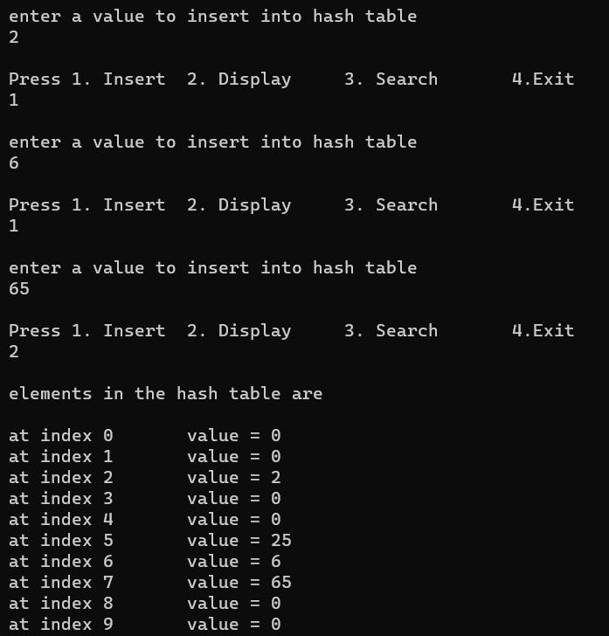

**PROGRAM4: To implement bubble sort.**

**Code:**

#include<stdio.h>

int main()

{

int array[100], n, i, j, swap;

printf("Enter number of elements:");

scanf("%d", &n);

printf("Enter %d Numbers:", n);

for(i = 0; i < n; i++)

scanf("%d", &array[i]);

for(i = 0 ; i < n - 1; i++)

{

for(j = 0 ; j < n-i-1; j++)

{

if(array[j] > array[j+1])

{

swap=array[j];

array[j]=array[j+1];

array[j+1]=swap;

}

}

}

printf("Sorted Array:");

for(i = 0; i < n; i++)

printf("%d ", array[i]);

return 0;

}

**Sample Input & Output:**

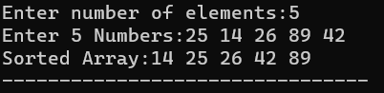

**PROGRAM5: To implement insertion sort.**

**Code:**

#include <stdio.h>

int main()

{

int n, array[1000], c, d, t;

printf("Enter number of elements\n");

scanf("%d", &n);

printf("Enter %d integers\n", n);

for (c = 0; c < n; c++) {

scanf("%d", &array[c]);

}

for (c = 1 ; c <= n - 1; c++) {

d = c;

while ( d > 0 && array[d] < array[d-1]) {

t = array[d];

array[d] = array[d-1];

array[d-1] = t;

d--;

}

}

printf("Sorted list in ascending order:\n");

for (c = 0; c <= n - 1; c++) {

printf("%d\n", array[c]);

}

return 0;

}

**Sample Input & Output:**

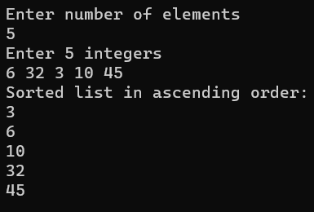

**PROGRAM6: To implement selection sort.**

**Code:**

#include <stdio.h>

int main()

{

int array[100], n, c, d, position, t;

printf("Enter number of elements\n");

scanf("%d", &n);

printf("Enter %d integers\n", n);

for (c = 0; c < n; c++)

scanf("%d", &array[c]);

for (c = 0; c < (n - 1); c++) // finding minimum element (n-1) times

{

position = c;

for (d = c + 1; d < n; d++)

{

if (array[position] > array[d])

position = d;

}

if (position != c)

{

t = array[c];

array[c] = array[position];

array[position] = t;

}

}

printf("Sorted list in ascending order:\n");

for (c = 0; c < n; c++)

printf("%d\n", array[c]);

return 0;

}

**Sample Input & Output:**

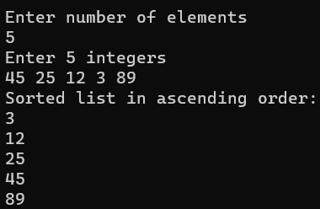

**PROGRAM7: To implement quick sort.**

**Code:**

#include <stdio.h>

int partition(int ar[], int low, int high)

{

int pivot = ar[high];

int i = low - 1;

for (int j = low; j < high; j++)

{

if (ar[j] <= pivot)

{

i++;

int temp = ar[i];

ar[i] = ar[j];

ar[j] = temp;

}

}

int temp = ar[i + 1];

ar[i + 1] = ar[high];

ar[high] = temp;

return i + 1;

}

void quickSort(int arr[], int low, int high)

{

if (low < high)

{

int pi = partition(arr, low, high);

quickSort(arr, low, pi - 1);

quickSort(arr, pi + 1, high);

}

}

int main(void)

{

puts("Enter the number of elements in the array: ");

int n;

scanf("%d", &n);

int arr[n];

puts("Enter the elements of the array: ");

for (int i = 0; i < n; i++)

{

printf("%d: ", i);

scanf("%d", &arr[i]);

}

quickSort(arr, 0, n - 1);

puts("The sorted array is: ");

for (int i = 0; i < n; i++)

{

printf("%d ", arr[i]);

}

}

**Sample Input & Output:**

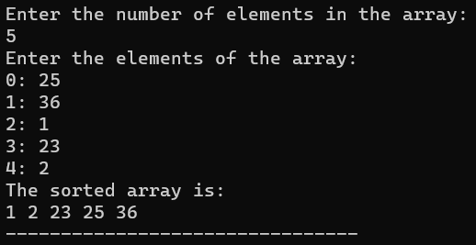

**PROGRAM8: To implement merge sort.**

**Code:**

#include <stdio.h>

void merge(int arr[], int l, int m, int r) {

int i, j, k;

int n1 = m - l + 1;

int n2 = r - m;

int L[n1], R[n2];

for (i = 0; i < n1; i++)

L[i] = arr[l + i];

for (j = 0; j < n2; j++)

R[j] = arr[m + 1 + j];

i = 0;

j = 0;

k = l;

while (i < n1 && j < n2) {

if (L[i] <= R[j]) {

arr[k] = L[i];

i++;

} else {

arr[k] = R[j];

j++;

}

k++;

}

while (i < n1) {

arr[k] = L[i];

i++;

k++;

}

while (j < n2) {

arr[k] = R[j];

j++;

k++;

}

}

void mergeSort(int arr[], int l, int r) {

if (l < r) {

int m = l + (r - l) / 2;

mergeSort(arr, l, m);

mergeSort(arr, m + 1, r);

merge(arr, l, m, r);

}

}

int main() {

int n;

printf("Enter the number of elements: ");

scanf("%d", &n);

int arr[n];

printf("Enter the elements:\n");

for (int i = 0; i < n; i++) {

scanf("%d", &arr[i]);

}

mergeSort(arr, 0, n - 1);

printf("Sorted array:\n");

for (int i = 0; i < n; i++) {

printf("%d ", arr[i]);

}

return 0;

}

**Sample Input & Output:**

